**S1 Robustness of data selection method**

To test the robustness of ozone trends results against the data/site selection method, we used two alternate methods to choose sites, as follows.

The first choice concerns the temporal continuity of valid data at each site, and it only includes sites with valid data in at least three years for every five years (1995–1999, 2000–2004, etc.) – this leads to a total of 481 sites (172 urban sites, 113 suburban sites, 196 rural sites). The spatial distribution of ozone trends in these 492 sites is consistent with the trends in the default 685 sites.

The second choice is much stricter, and it only selects 358 sites (121 urban sites, 92 suburban sites, 145 rural sites) with valid hourly data in 75% or more of hours during 1995–2012.

Table S1. Trends and correlations in observed European urban, suburban and rural average ozone during 1995–2012 calculated based on different data selection criteria 1.

|  |  |  |  |  |  |  |  |  |  |
| --- | --- | --- | --- | --- | --- | --- | --- | --- | --- |
| Data selection criteria | Ozone trend and correlation | | | | | | | | |
| Urban | | | Suburban | | | Rural | | |
|  | Trend | Corr.5 | De-trended Corr.6 | Trend | Corr.5 | De-trended Corr.6 | Trend | Corr.5 | De-trended Corr.6 |
| Default 2 | 0.53** |  |  | 0.21* |  |  | -0.01 |  |  |
| Data-continuity 3 | 0.56** | 0.85** | 0.84** | 0.22* | 0.82** | 0.81** | -0.02 | 0.80** | 0.82** |
| Data-coverage 4 | 0.51** | 0.83** | 0.82** | 0.19* | 0.83** | 0.84** | -0.01 | 0.82** | 0.82** |

1. ** P-value < 0.01, * P-value < 0.05 under an *F*-test for trends and a one-sided *T*-test for correlation.
2. based on data in the 685 sites, our default choice.
3. based on data in the 492 sites covering the sites with valid data in at least three years for every five years.
4. based on 373 sites with more than 75% of hourly data available in all years.
5. Correlation between the European annual ozone time series in a sensitivity case and the time series in the default case.
6. Similar to 5 but for de-trended ozone.

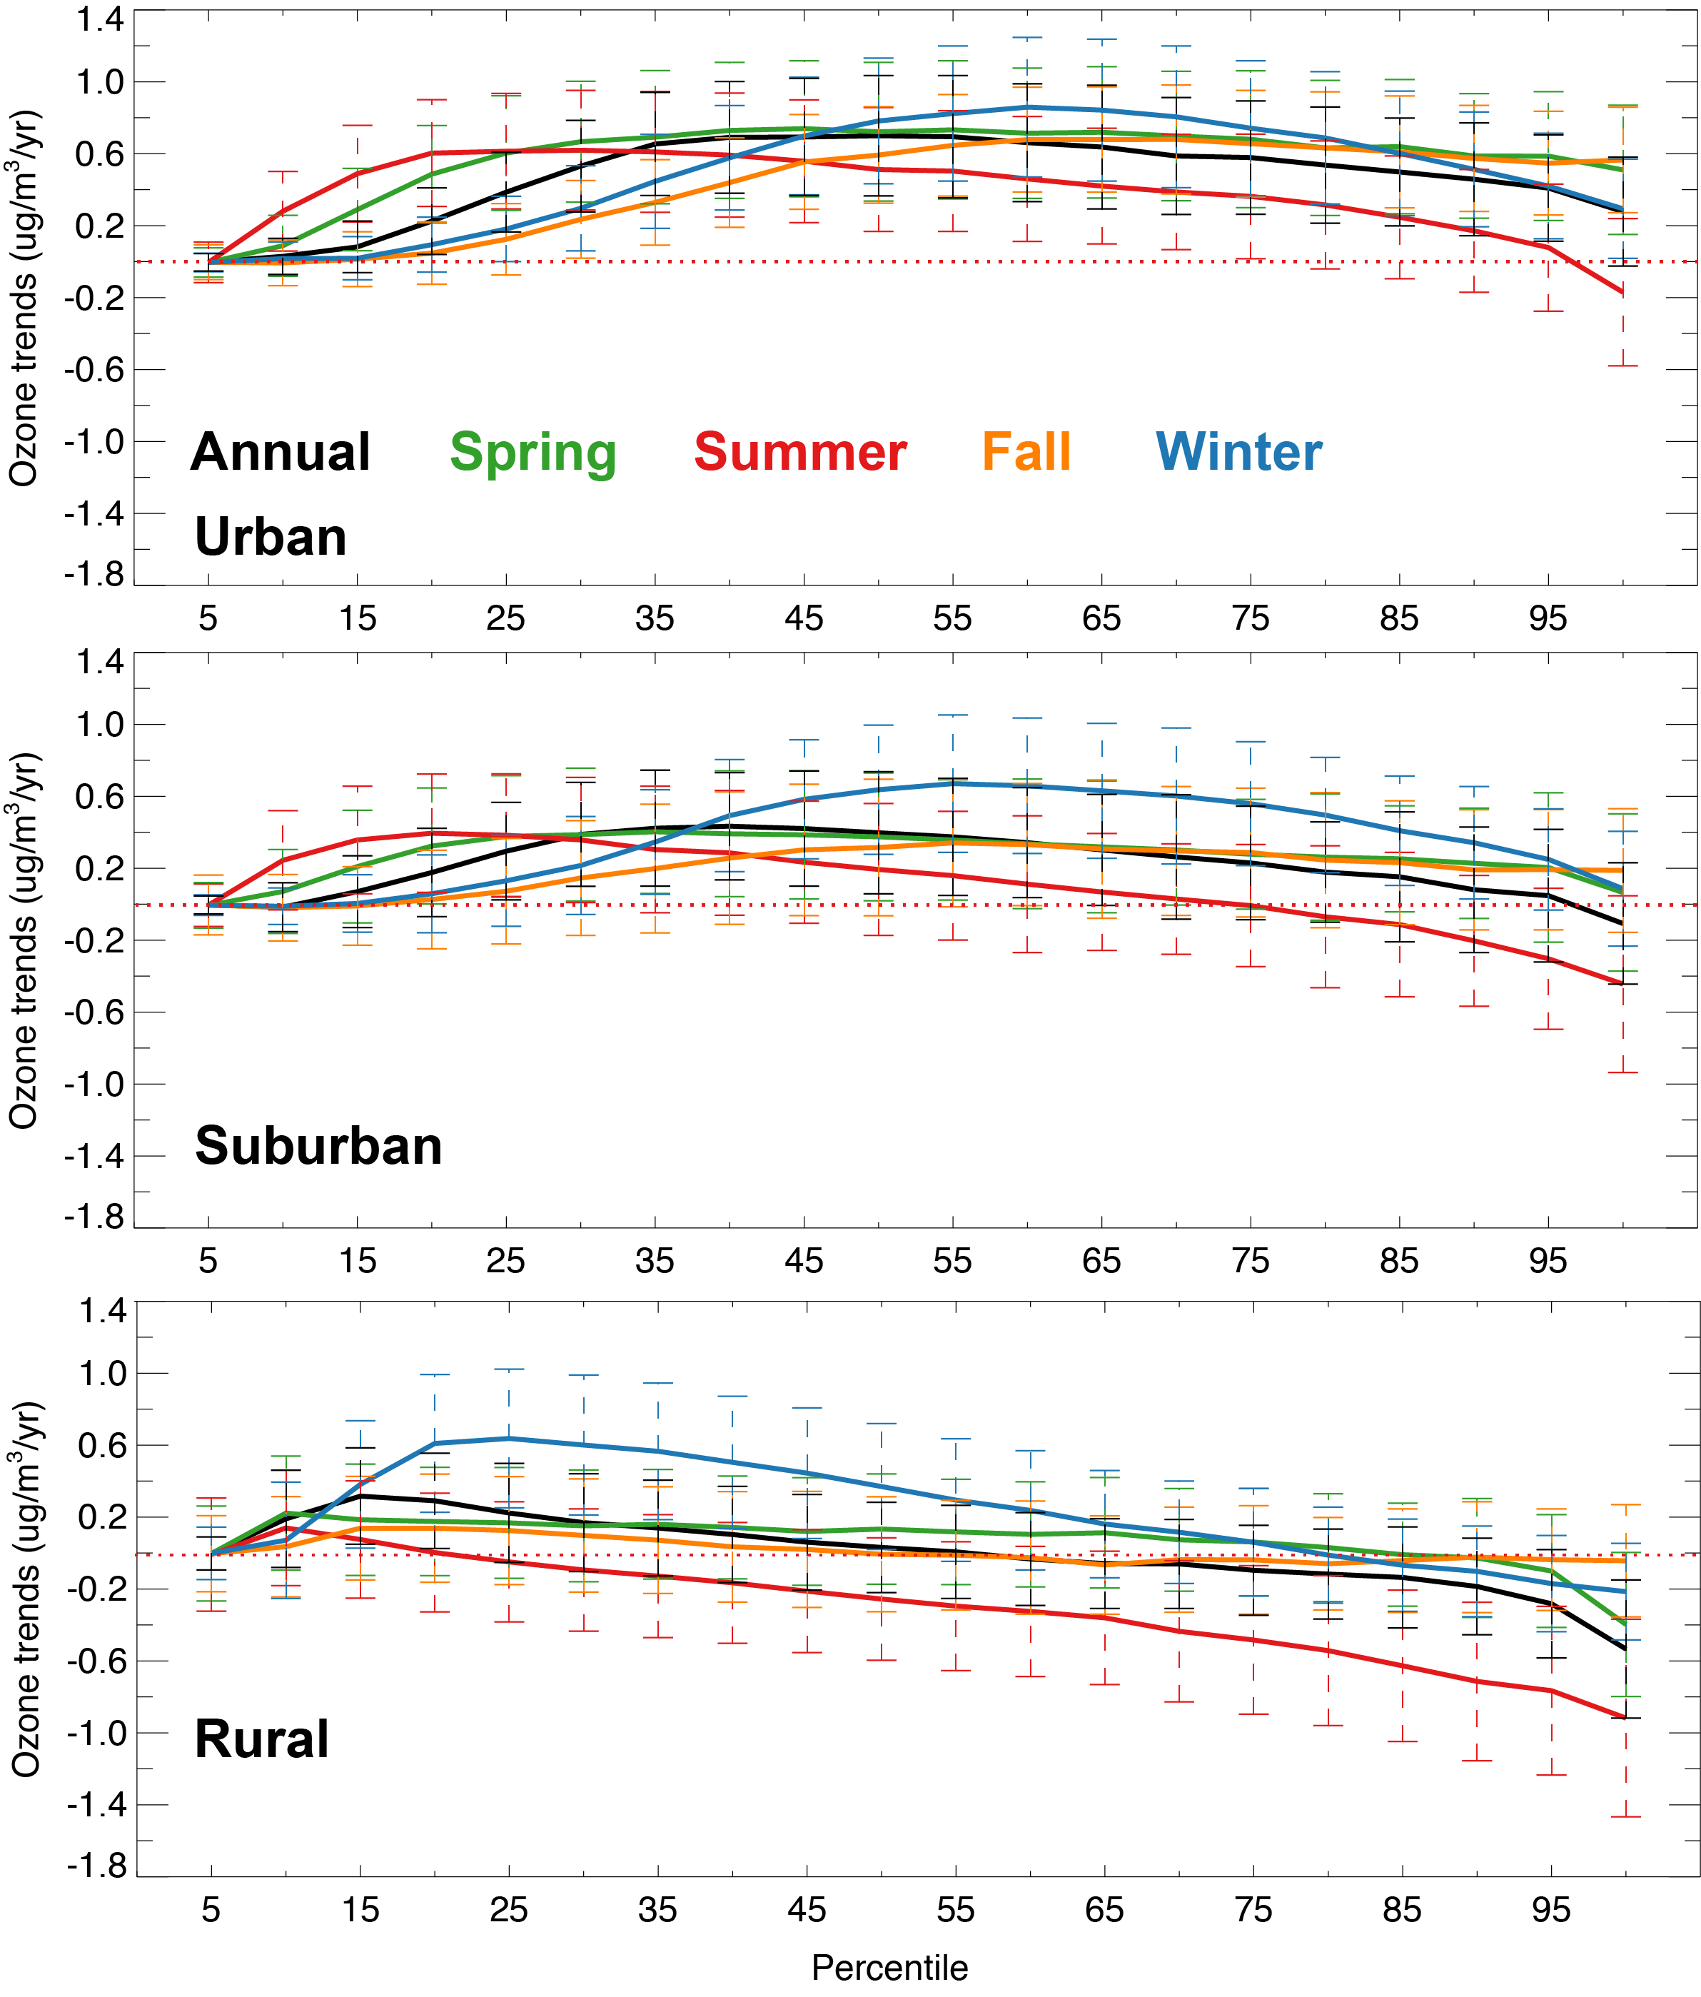

Fig. S1 Trends in observed nighttime surface ozone averaged over Europe, calculated based on data from the urban, suburban and rural sites. The black line shows the 1995–2012 linear trends in the deseasonalized European monthly ozone anomalies for each 5th percentile, the green, red, yellow and blue lines depict the observed trend for seasonal ozone, and the dashed bars indicate their deviations.

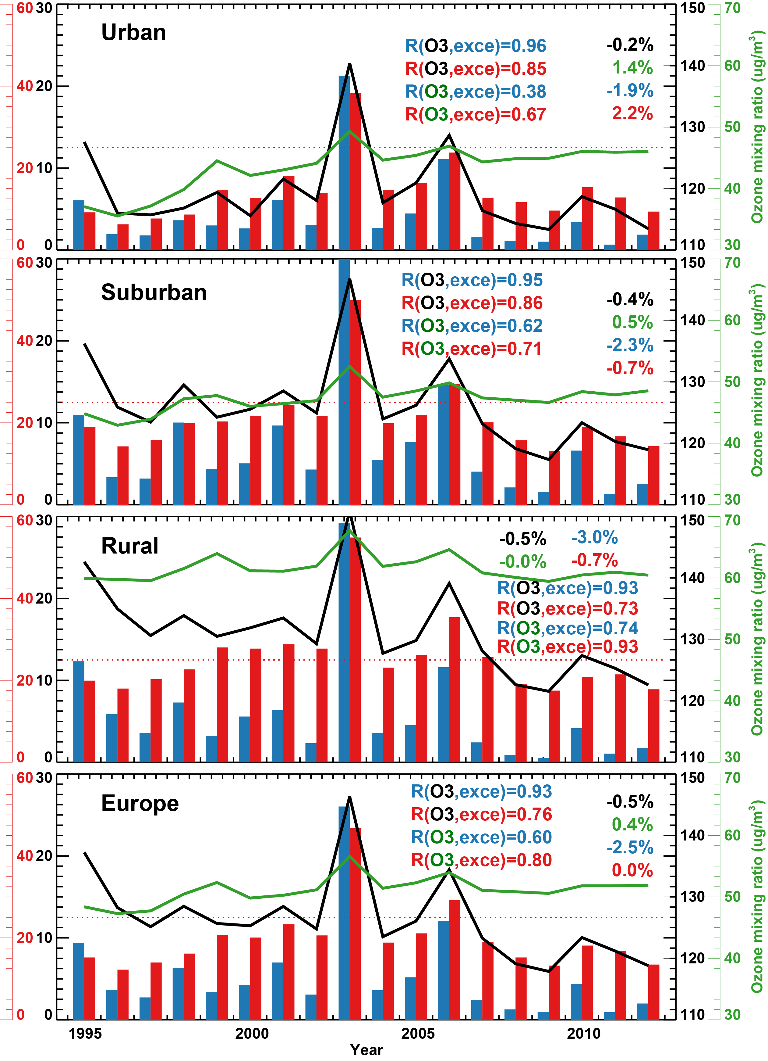

Fig. S2 Annual exceedances of the information threshold, i.e., the 1-hourly average of 180 µg/m3 (blue bars show hours times the number of sites) as well as the long-term objective, i.e., the 8-hourly mean of 120 µg/m3 (red bars show days times twice the number of sites), compared with the annual mean (green lines) and 95th percentile ozone concentrations (black lines). Red dotted line shows the target value (long-term objective not to be exceeded more than 25 days per year, averaged over 3 years). Also shown in each panel are their linear trends and correlations between ozone and exceedances.